
Final Power BI Project
Ali Magdy Mahmoud


Project Overview

Dataset for project
apple_product_pricing_2020_2026.csv

Business Problem
Apple needs a dashboard to analyze product pricing, discounts, ratings, and customer engagement to support pricing decisions.

Data Model

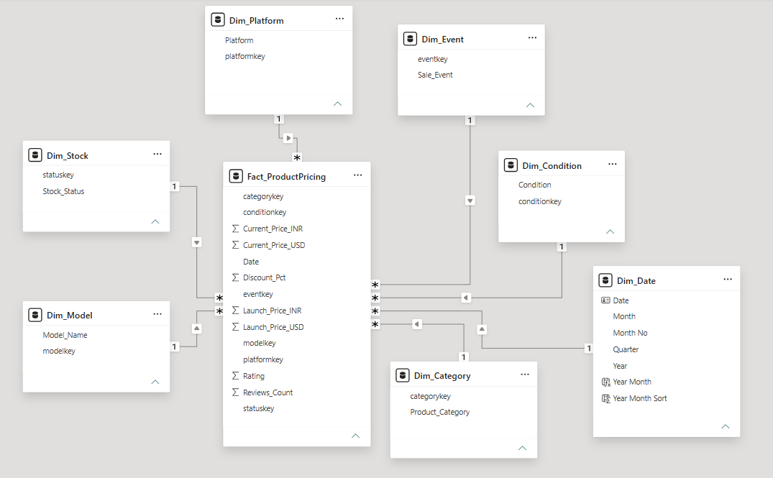

In this model, we have:
- One Fact Table
- Seven-Dimension Tables

The Schema
Star Schema
because:
- Dimension represented by one-table
- Fact table surrounded by dimension tables
- Less join
- Simple design

The grain
Product which is recorded or updated in specific date

Data Mapping
Source Column | Source Table | Target Table | Target Column
Stock_Status | apple_products_pricing_2020_2026 | Dim_Stock | Stock_Status
Model_Name | apple_products_pricing_2020_2026 | Dim_Model | Model_Name
Product_Category | apple_products_pricing_2020_2026 | Dim_Category | Product_Category
Sale_Event | apple_products_pricing_2020_2026 | Dim_Event | Sale_Event
Platform | apple_products_pricing_2020_2026 | Dim_Platform | Platform
Condition | apple_products_pricing_2020_2026 | Dim_Condition | Condition
Date | apple_products_pricing_2020_2026 | Dim_Date | Date

Data Dictionary
Column | Description
Date | The date when the product price was recorded or updated.
Platform | The e-commerce platform where the product is listed
Product_Category | The category to which the product belongs
Model_Name | The specific model or name of the product.
Condition | The condition of the product, such as New, Used, or Refurbished.
Launch_Price_USD | The product's original launch price in US Dollars (USD).
Launch_Price_INR | The product's original launch price in Indian Rupees (INR).
Current_Price_USD | The current selling price of the product in US Dollars (USD).
Current_Price_INR | The current selling price of the product in Indian Rupees (INR).
Discount_Pct | The percentage discount applied to the current price compared to the launch price.
Sale_Event | The promotional event during which the product is being sold
Stock_Status | Indicates whether the product is currently available for purchase
Rating | The average customer rating of the product, typically measured on a scale from 1 to 5
Reviews_Count | The total number of customer reviews submitted for the product.

Fact Table
Fact_ProductPricing
Columns
Column | Datatype | Description
Date | Date | Foreign Key
categoryKey | text | Foreign Key
conditionKey | text | Foreign Key
eventkey | text | Foreign Key
modelkey | text | Foreign Key
platformkey | text | Foreign Key
statuskey | text | Foreign Key
Current_Price_INR | Decimal number | Measure (Fact)
Current_Price_USD | Decimal number | Measure (Fact)
Launch_Price_INR | Decimal number | Measure (Fact)
Launch_Price_USD | Decimal number | Measure (Fact)
Rating | Decimal number | Measure (Fact)
Review Count | Whole Number | Measure (Fact)
Discount_Pct | Decimal number | Measure (Fact)

Dimension Tables
- Dim_Platform
Columns
Column | Datatype | Description
Platform | text | attribute
platformkey | text | Surrogate Key

- Dim_Stock
Columns
Column | Datatype | Description
Stock_Status | Text | attribute
statuskey | Text | Surrogate Key

- Dim_Model
Columns
Column | Datatype | Description
Model_Name | Text | attribute
modelkey | Text | Surrogate Key

- Dim_Event
Columns
Column | Datatype | Description
Sale_Event | Text | attribute
eventkey | Text | Surrogate Key

- Dim_Condition
Columns
Column | Datatype | Description
Condition | Text | attribute
conditionkey | Text | Surrogate Key

- Dim_Date
Columns
Column | Datatype | Description
Date | Date | Surrogate key
Month | Text | attribute
Month No | Whole number | attribute
Quarter | Text | attribute
Year | Whole number | attribute
Year Month | Text | Calculated column
Year Month Sort | Whole number | Calculated column

- Dim_Category
Columns
Column | Datatype | Description
Product_Category | Text | attribute
categorykey | Text | Surrogate Key

Note
- We used date column as a surrogate key as it is easy to use for time intelligence functions

DAX Calculations
- Basic / KPI Measures

- Average Current Price
- Average Launch Price
- Average Savings
- Average Discount %
- Average Rating
- Total Reviews
- Highest Current Price
- Lowest Current Price
- Product Count
- Product on Sale
- Stock Availability %

- Dynamic Currency Measures
Because we have two currencies: INR & USD so we made a dynamic measure changes according to your choice and apply it to these measures:
- Current Price
- Launch Price
- Highest Price
- Lowest Price

Note
Current Price: Calculates the average current price of products based on the selected filters and currency. It’s just a name for the average current price

- Time Intelligence Measures

- Current Price MTD
- Current Price QTD
- Current Price YTD
- Avg Current Previous Year
- YoY Growth %
- Rolling 3 Months Avg

- Analysis / Business Measures

These Measures are related to the analysis that we’re doing. For Example:
Sale Event
- Products on Sale
- Average Discount by Sale Event
- Average Savings by Sale Event
- Average Rating by Sale Event
- Total Reviews by Sale Event
Category
- Product Count by Category
- Average Current Price by Category
- Average Discount by Category
- Average Rating by Category
Platform
- Product Count by Platform
- Average Current Price by Platform
- Average Rating by Platform
- Average Discount by Platform
The Pros here that we don’t have to create specific measures for these attributes

- Supporting Measures

Intermediate measures used by other calculations

Note:
- All DAX measures created during the project, including the core, time intelligence, supporting, and analytical measures, are available in the dedicated Measures table within the Power BI project file.

Dashboard:
Home Page
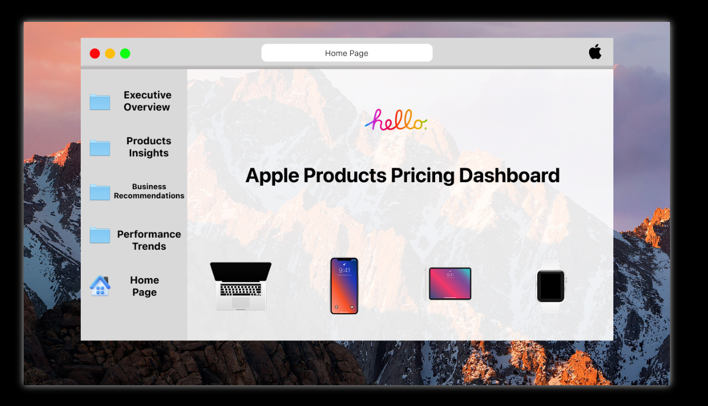
Executive Overview
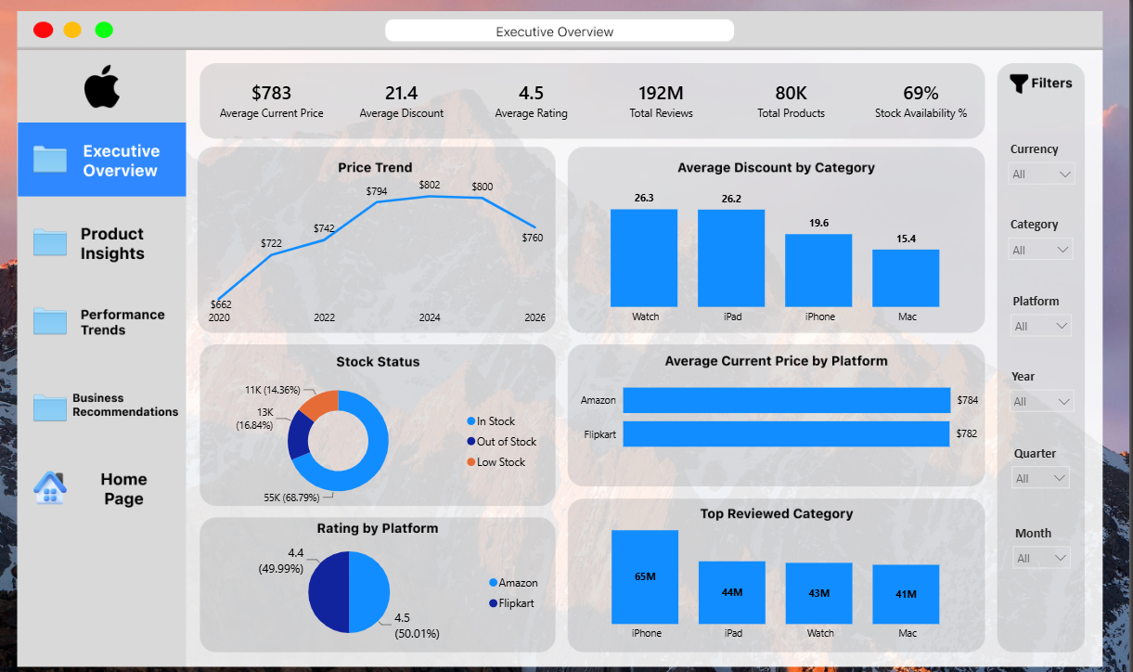
Product Insights
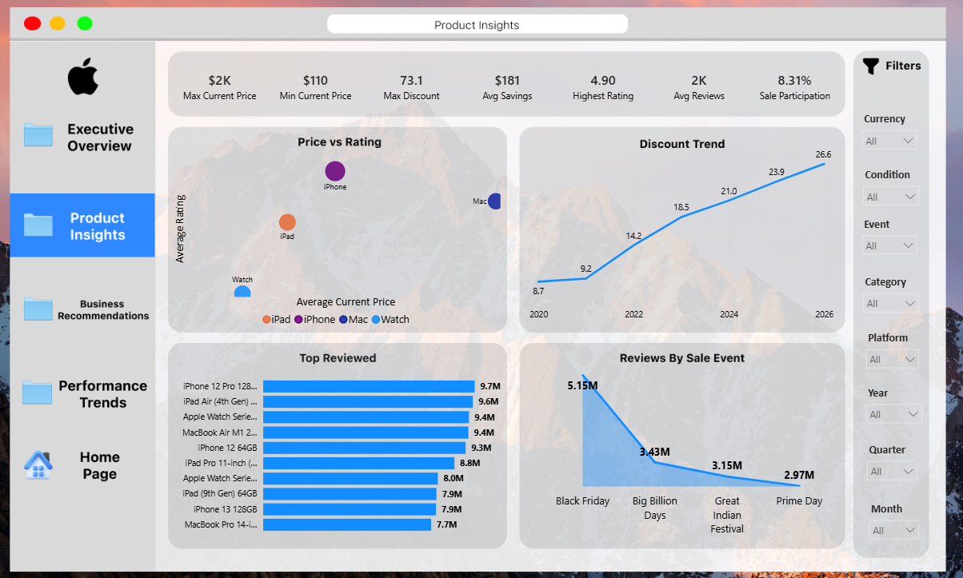
Performance Trends
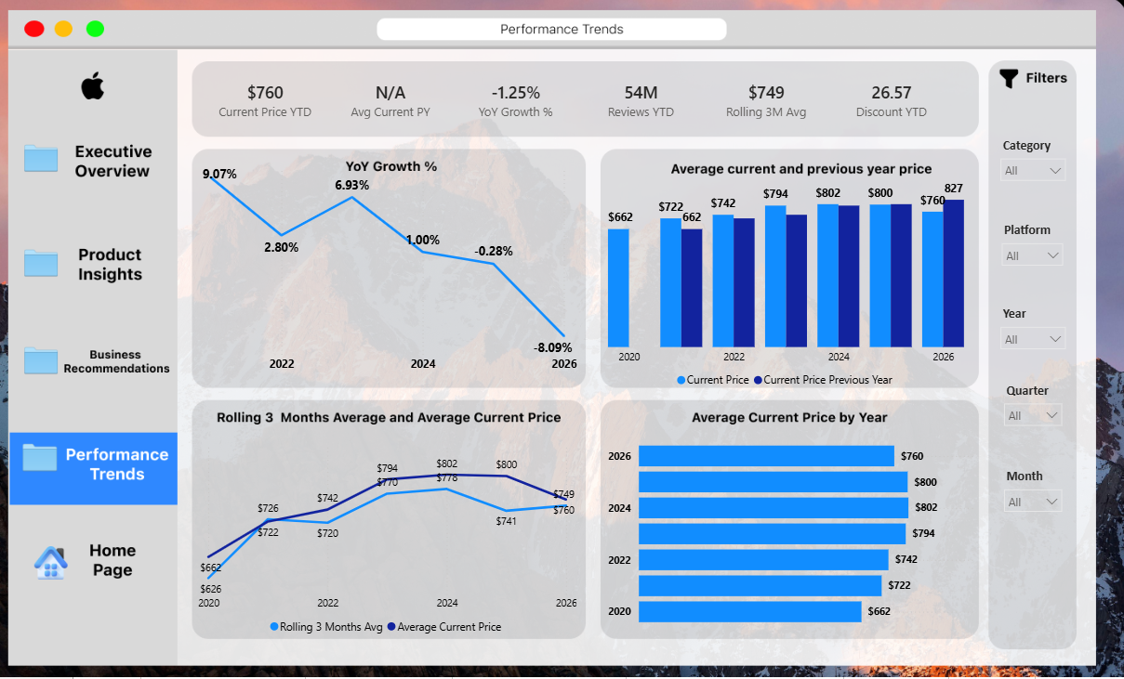
Categories Insights:
MacBook
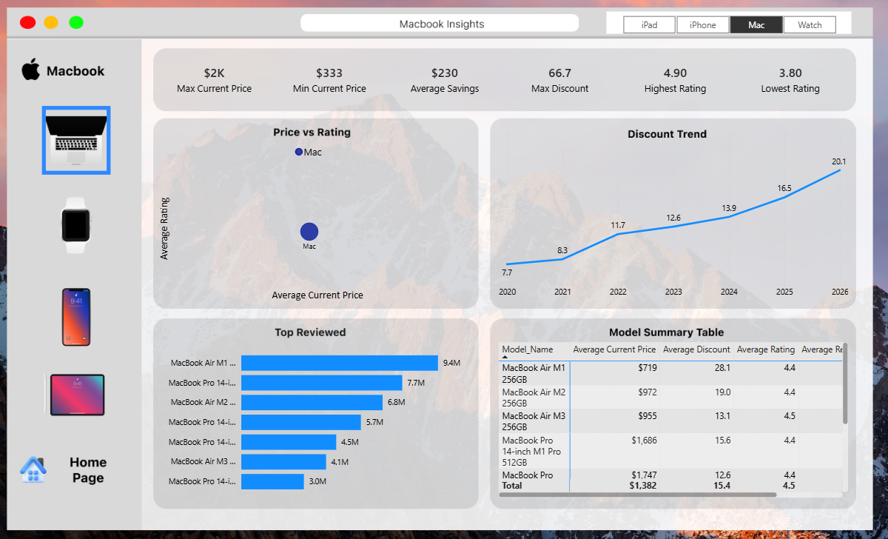
Watch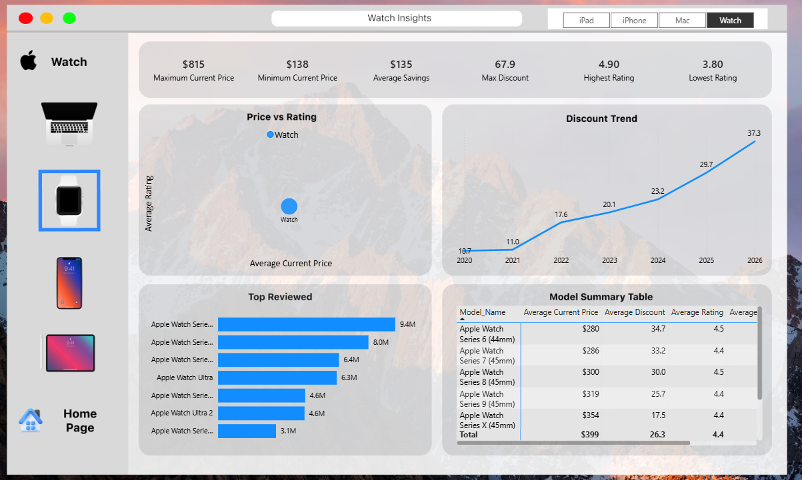
iPhone
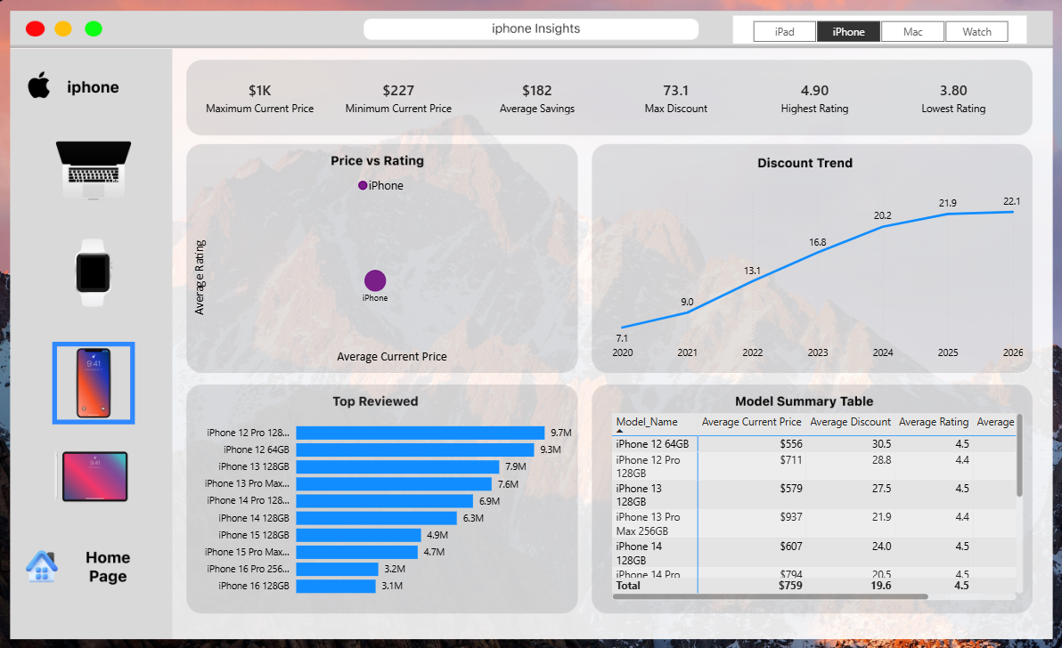
iPad
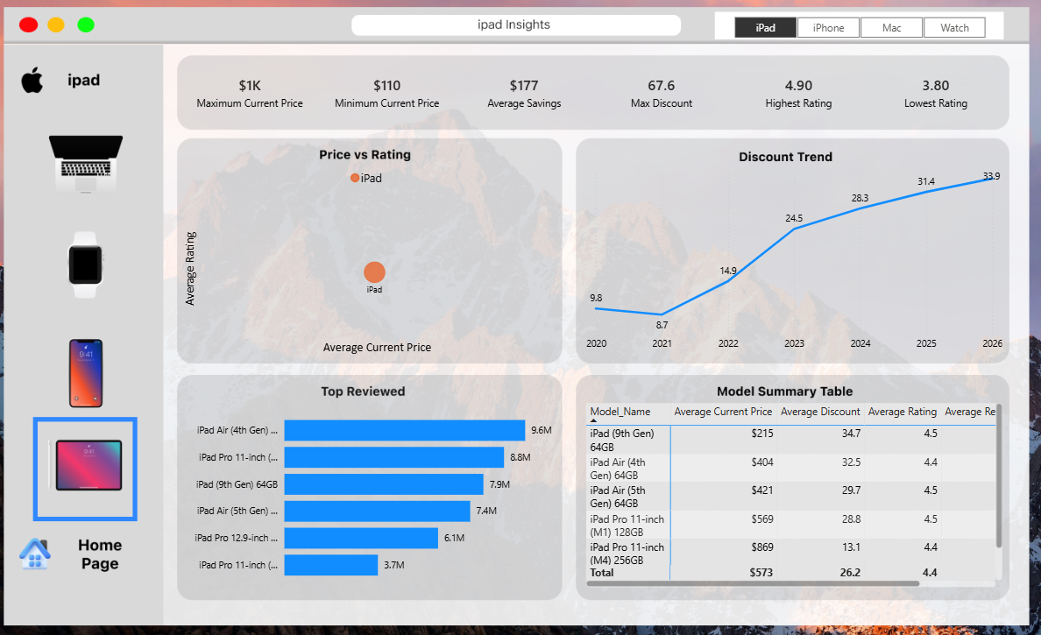
Business Questions
Pricing
  - How has the average current price changed over time?
Answer: Average product prices reached their highest level in 2024 and subsequently declined, with 2026 recording an 8.09% year-over-year decrease
  - Which product categories have the highest and lowest average current prices?
Answer: Product Category with highest price: iPhone
Product Category with lowest price: Watch
  - Is the average current price increasing or decreasing year over year?
Answer: Average product prices reached their highest level in 2024 and subsequently declined, with 2026 recording an 8.09% year-over-year decrease
  - Which products have the highest and lowest current prices?
MacBook: Highest MacBook Pro 14-inch M4 Pro 512GB/Lowest MacBook Air M1 256GB
Watch: Highest Apple Watch Ultra 2/Lowest Apple Watch Series 6 (44mm)
iPhone: Highest iPhone 15 Pro Max 256GB /Lowest iPhone 12 64GB
iPad: Highest iPad Pro 12.9-inch (M2) 256GB/Lowest iPad (9th Gen) 64GB
  - How do prices differ between Amazon and Flipkart?
Avg Current Price in Amazon reaches to $784, while in Flipkart it’s $782
  - How does the current price compare with the previous year's price?
Prices was increasing between 2020 to 2024, but in 2025 the prices started to decline and this is a small comparison between prices
• 2020 → $662
• 2021 → $722
• 2022 → $742
• 2023 → $794
• 2024 → $802
• 2025 → $800
• 2026 → $760

Discounts & Promotions
- How has the average discount changed over time?
Average discounts have increased substantially over time, rising from 8.7% in 2020 to 26.6% in 2026
- Which product categories receive the highest discounts?
Watch receives the highest discounts with average discount reaches to 26.3, while iPad in the second place with average discount to 26.2
- Which sale events generate the highest customer engagement based on reviews?
Black Friday has the highest review activity among the analyzed sale events, with approximately 5.15M reviews
- How much average savings do customers receive across product categories?
In General, Avg Savings: $181
With Categories: MacBook:$230/iPhone:$182/Watch:$135/iPad:$177
- Are discounts becoming more aggressive over time?
Of Course, In 2020 the average discount was 9.8 , and by 2026 it reaches to 33.9

Product Performance

- Which product category receives the highest number of reviews?
iPhone receives the highest number of reviews with 65M reviews
- Which individual products receive the highest number of reviews?
The individual products which receive the highest number of reviews are:
- iPhone 12 Pro 128GB
- iPad Air (4th Gen) 64GB
- Apple Watch Series 6 (44mm)
- MacBook Air M1 256GB

- How does product price relate to product rating?
From Product Insights, we found that:
iPhone is the only category that has high price + high engagement. On the other side, the other categories may have high price + lower engagement and vice versa
- Which product categories combine high ratings with strong customer engagement?
iPhone is the product categories combine high ratings with strong customer engagement with average price $759 and rating 4.5

Inventory

- What percentage of products are currently in stock, low stock, or out of stock?
In Stock: 68.79%
Low stock: 14.36%
Out of stock: 16.84%
- Are there inventory availability concerns that may affect highly reviewed products?
Inventory availability may pose a potential risk to highly reviewed products

Platform Performance
- Which platform has the higher average product price?
Amazon is the platform which has the higher average product price with $784
- Which platform has the higher average product rating?
Amazon is the platform which has the higher average rating with 4.5
- Is there a significant pricing difference between Amazon and Flipkart?
There is no significant pricing difference between Amazon and Flipkart. The average current price on Amazon is $784 compared with $782 on Flipkart, a difference of only $2

Business Insights
Insight 1 — Average Price peaked then declined
Average product prices reached their highest level in 2024 and subsequently declined, with 2026 recording an 8.09% year-over-year decrease
Executive Overview + Performance Trends:
- 2020 → $662
- 2021 → $722
- 2022 → $742
- 2023 → $794
- 2024 → $802
- 2025 → $800
- 2026 → $760

Insight 2 — Discounts are increasing significantly

Average discounts have increased substantially over time, rising from 8.7% in 2020 to 26.6% in 2026.

From Product Insights:
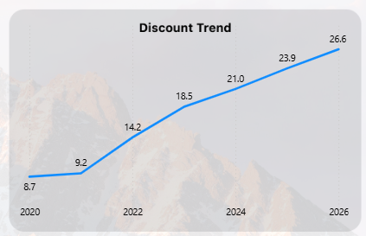

Insight 3 — Discounts are increasing while prices are declining

The increase in discount levels coincides with a decline in average current prices, suggesting a shift toward more aggressive promotional pricing

For Example:

2024
- Average Price = $802
- Discount = 21.0%

2026
- Average Price = $760
- Discount = 26.6%

Insight 4 — Watch and iPad have the highest discounts

Watch and iPad products receive the highest average discounts, while Mac products have the lowest average discount

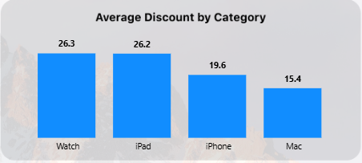

Insight 5 — iPhone has the highest customer engagement

iPhone has the highest customer engagement, generating approximately 65M reviews, significantly higher than the other product categories.

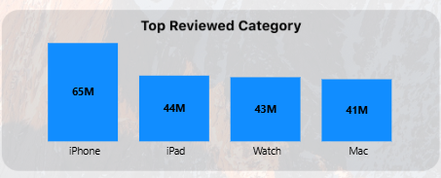

Insight 6 — Black Friday has the highest review activity among sale events
Black Friday has the highest review activity among the analyzed sale events, with approximately 5.15M reviews.
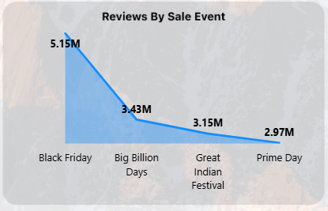

Insight 7 — Sale participation is relatively limited

Only 8.31% of products participate in sale events, indicating that promotional campaigns are applied to a relatively limited portion of the product portfolio.

Insight 8 — Inventory availability needs monitoring

Approximately 31.2% of products are either low in stock or out of stock, indicating a potential inventory availability concern.

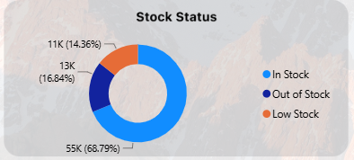

Insight 9 — Platforms have almost identical prices

Amazon and Flipkart show very similar average current prices, while Amazon has a slightly higher average rating.

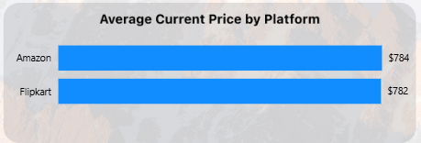

Insight 10 — Product categories have different pricing strategies

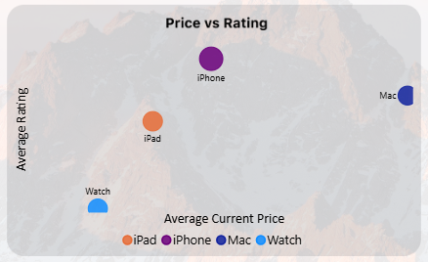

Business Recommendations

Recommendation 1
Optimize Promotional Discounts
Insight:
Discounts increased from 8.7% in 2020 to 26.6% in 2026, while average current price declined from its peak.
Recommendation:
Review and optimize discount levels to avoid excessive reliance on promotions and protect product profitability.
Action:
Apply higher discounts selectively to products that need stronger promotional support instead of increasing discounts across the entire portfolio.

Recommendation 2
Prioritize Inventory Replenishment
Insight:
31.2% of products are either Low Stock or Out of Stock.
Recommendation:
Prioritize inventory replenishment for high-engagement products to reduce potential availability issues.
Action:
Give priority to highly reviewed categories and products, particularly iPhone products, when allocating inventory.

Recommendation 3
Leverage High-Engagement Sale Events
Insight:
Black Friday has the highest review activity:
5.15M reviews
compared with:
- Big Billion Days → 3.43M
- Great Indian Festival → 3.15M
- Prime Day → 2.97M
Recommendation:
Prioritize major promotional campaigns around high-engagement sale events such as Black Friday.
Action:
Focus promotional planning and product visibility on events that demonstrate stronger customer engagement

Recommendation 4
Use Category-Specific Discount Strategies
Insight:
Watch = 26.3%
iPad = 26.2%
iPhone = 19.6%
Mac = 15.4%
Recommendation:
Adopt category-specific discount strategies rather than applying uniform discount levels across all product categories.
Action:
Review whether the high discount levels for Watch and iPad products are generating sufficient customer engagement to justify the promotional cost

Recommendation 5
Monitor Pricing Trends
Insight:
Average Current Price:
2024 → $802
2026 → $760

YoY Growth 2026:
-8.09%
Recommendation:
Closely monitor pricing trends and investigate the drivers behind the recent decline in average product prices.
Action:
Use YoY growth and rolling averages as early indicators for pricing adjustments and promotional planning.

Recommendation 6

Maintain Platform Price Consistency
Insight:
- Amazon = $784
- Flipkart = $782

Recommendation:
Maintain competitive price consistency across Amazon and Flipkart while monitoring platform-specific customer engagement

